**Implement GitLab Operations using Git:**

Trisha Balakrishnan

21011102105

IoT-B

1. Creating a Repository
2. Cloning a Repository
   1. Use ***git clone <repository_url>***  with the URL you copied from GitLab

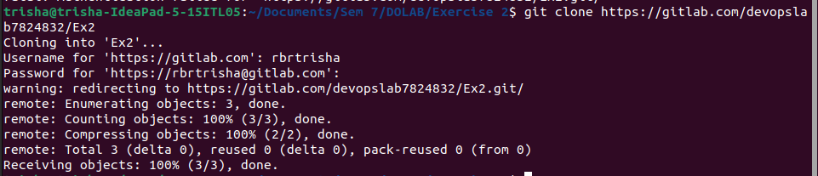

1. Making Changes and Creating a Branch
   1. Navigate into the cloned repository
   2. Create a new text file named "filename.txt" using a text editor.
   3. Add some content to the " filename.txt" file.
   4. Save the file and return to the command line.
   5. Check the status of the repository

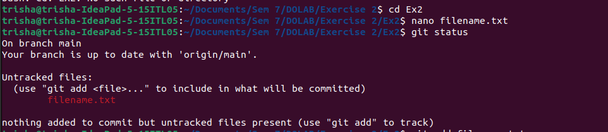

* 1. Stage the changes for commit
  2. Commit the changes with a descriptive message *"Edited_example.txt"*

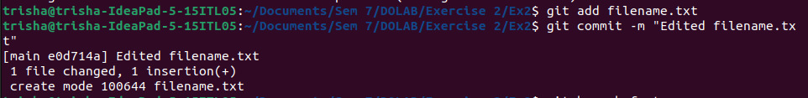

* 1. Create a new branch named "feature"
  2. Switch to the "feature" branch
  3. Pushing Changes to GitLab



1. Add Repository URL in a variable
   1. Add Repository URL in a variable
   2. Replace <repository_url> with the URL you copied from GitLab
   3. Push the "feature" branch to GitLab

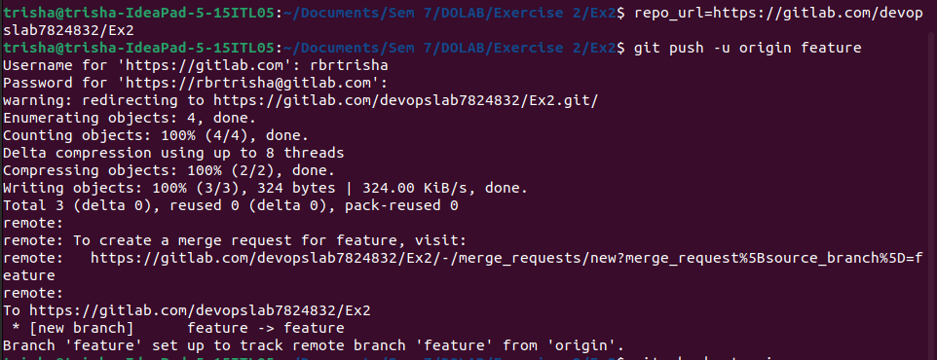

* 1. Check your GitLab repository to confirm that the new branch "feature" is available.

1. Collaborating through Merge Requests
   1. Create a merge request on GitLab
   2. Review and merge the merge request
2. Syncing Changes
   1. After the merge request is merged, update your local repository

